RPC-130E
Reactive Power Compensation Controller
Instruction Manual

Instruction Manual
V1.2

ZHEJIANG ROCKWELL ENERGY TECHNOLOGY CO.,LTD.

contents
1 Overview 4
2 Technical Features 4
2.1 Flexible Control Methods 4
2.2 Optimized Control Scheme 4
2.3 Anti-oscillation During Control 4
2.4 Comprehensive Historical Records 5
2.5 Reliable Blocking Function 5
2.6 Intuitive and Easy-to-Use Interface 5
2.7 Detailed Technical Function 5
3 Technical Specification 6
4 Control Strategy 9
4.1 Power Factor-Based Switching 9
4.2 Reactive Power Switching 10
4.3 Switching Modes 11
5 Capacitor Bank Protection Functions 11
5.1 Time-limited Instantaneous Overcurrent Protection (Stage I Current Protection) 11
5.2 Overcurrent Protection (Stage II Current Protection) 11
5.3 Open-delta Voltage Protection 12
5.4 Unbalanced Current Protection 12
5.5 Harmonic Current Protection 12
5.6 Harmonic Voltage Protection 13
5.7 Overvoltage Protection 13
5.8 Undervoltage Protection 13
5.9 High-temperature Fan Start-up* (This is an optional setting function) 14
5.10 Over-temperature Protection* (This is an optional setting function) 14
6 Menu Operation Instructions 14
6.1 Main Menu 15
6.2 Real-time Data 15
6.3 Harmonic Analysis 16
6.4 Operation Records 16
6.5 Data Statistics 17
6.6 Compensation Parameters 18
6.7 Capacitor Parameters (The table below shows parameters for a single bank; the parameters are identical for all 3 banks) 20
6.8 Serial Communication 21
6.9 Date and Time 22
6.10 Factory Test 22
7 Equipment Installation, Terminal Wiring, and Power-On Operation 22
7.1Cutout Dimensions 22
7.2 Controller Terminal Wiring 23
7.3 Powering On the Device and Checking Status 23
7.4 Parameter Setting 23
8 Device Commissioning 23
8.1 Purpose of Commissioning 23
8.2 Commissioning Methods 24
8.3 Common Abnormal Conditions and Troubleshooting 24
9 After-sales Commitment 26
9.1 Product Quality Commitment 26
9.2 Product Price Commitment 26
9.3 Delivery Time Commitment 26
9.4 After-sales Service Commitment 26
9.5 Order Instructions 27

1 Overview
This series of voltage and reactive power integrated controllers is applicable to the automatic control and protection of single main transformers, single power supply lines, and 1~3 groups of capacitors. By comprehensively considering voltage fluctuations and reactive power deficits, the algorithm reasonably controls the switching of capacitors to meet the balance of reactive power supply and demand in the power grid, improve power supply voltage quality, reduce power loss, and thus achieve the goals of improving power supply quality, increasing power factor, and reducing system loss.

2 Technical Features

2.1 Flexible Control Methods
According to different application scenarios, the controller supports multiple control and switching modes for capacitor banks: equal-capacity (cyclic), unequal-capacity (intelligent combination), filtering (sequential switching on and reverse switching off), and photovoltaic field control mode. It allows setting the upper and lower limits of power factor separately for inductive and capacitive conditions to rationally switch capacitor banks while considering reactive power. Through the combination of different control methods, it can meet the reactive power compensation control requirements of multiple scenarios, such as substations, power lines, end users, no-load compensation, distributed photovoltaics, harmonic control, and charging stations.

2.2 Optimized Control Scheme
Under the fully automatic control mode, the controller can automatically determine the status of the controlled capacitor banks based on the system's current analog data and relevant binary input signals, and select the optimal control scheme without manual intervention.

2.3 Anti-oscillation During Control
(1) During normal operation of the power system, the load changes at any time, making it difficult to determine the reactive power setting value. However, the allowable range of the system's power factor is clearly specified. Therefore, the controller replaces the setting of reactive power load limits with a configurable ideal power factor range, and ultimately uses system voltage and reactive power as the basic operating conditions. This effectively prevents problems such as the device refusing to operate or operating frequently due to inaccurate reactive power load settings.
(2) In addition to the input delay configurable by the user, the controller also provides "reverse delay" (output delay), which fully ensures that the device does not issue opposite operation commands to the same control object within the specified time, which is very conducive to maintaining system stability.

2.4 Comprehensive Historical Records
The controller has powerful storage and recording capabilities with detailed historical records. It can simultaneously store the operation times, operation time records, and fault information records of 3 groups of capacitors.

2.5 Reliable Blocking Function
(1) The controller can receive abnormal operation or protection action signals from controlled objects (main transformers, capacitor banks) to block relevant operations, ensuring the safety of the automatic control process.
(2) When the capacitor bank refuses to operate or fails, the controller automatically blocks the control of the corresponding object.
(3) The controller has perfect self-diagnosis capabilities, which can timely detect its own hardware faults during operation. Once an abnormality is detected in the self-check, all operation commands are blocked, and an alarm signal for device self-check abnormality is output at the same time.
(4) When the system is over-voltage or under-voltage, the capacitor bank is disconnected and all operation commands are blocked.

2.6 Intuitive and Easy-to-Use Interface
The controller adopts a 7-inch color touch screen with a resolution of 800*480, supporting Chinese and English interfaces and menu-based operation. The human-machine interface display is intuitive and easy to operate.

2.7 Detailed Technical Function
Technical Features
Grouping Mode |  | Harmonic Functions |  | Auxiliary Functions |  | Power Supply
Equal/Unequal Capacity | ● | Harmonic Display | ● | Temperature Detection | ● | AC 100~240V  ±15% | ●
Filtering | ● | Harmonic Protection | ● | Cloud Service Function | * | DC 100~240V  ±15% | ●
Capacitor Regulation Method |  | Human-Machine Interface |  | Dimensions (mm) |  | Communication Interface
Grouped Switching, 1–3 Banks | ● | 800×480 (7-inch Color Touch Screen) | ● | 240×170×100 | ● | RS485 | ●
Switching Criterion |  | Main Functions |  | Group Protection Functions |  | Communication Protocol
Reactive Power | ● | System Harmonic Analysis | ● | Overvoltage Protection | ● | Modbus-RTU | ●
Power Factor | ● | Harmonic Analysis for 3 Capacitor Circuits | ● | Undervoltage Protection | ●
 |  | Event Action Function | ● | Harmonic Protection | ●
 |  | Fault Recording Function | ● | Open-delta Voltage Protection / Zero-sequence Current Protection  Overcurrent Protection | *
 |  | Low Current Blocking | ● |  | *
 |  | Chinese/English Interface | ● | Time-limited Instantaneous Overcurrent Protection | ●
 |  | Factory Simulation Test | ● | Ground Fault Protection | ●
 |  | Reminder Function (Note: This refers to a custom feature in some controllers) | ● | Temperature Detection and Protection | ●
 |  |  |  | Auxiliary Functions | *
- Note: The above functions represent all features of various controller versions. The actual functions depend on the specific model selected. Features marked with * are optional.

3 Technical Specification

- Item No. | - Item | - Sub-item | - Technical Specification
- 3.1 | - Dimensions & Opening Dimensions​ | - Overall Dimensions | - 240 × 170 × 100 (L × W × H, mm)
- 3.1 | - Dimensions & Opening Dimensions​ | - Opening Dimensions | - 216 × 158 (L × W, mm)
- 3.2 | - Operating Power Supply​ | - Operating Power Source | - AC/DC 100~240V (*)
- 3.3 | - Rated Sampling​ | - Rated Voltage | - AC 100V / ±0.5%
- 3.3 | - Rated Sampling​ | - Rated Current | - 1A / 5A / ±0.5% (*)
- 3.4 | - Operating Environment​ | - Operating Temperature | - -20°C ~ +70°C (or -40°C ~ +85°C)
- 3.4 | - Operating Environment​ | - Relative Humidity | - ≤95%
- 3.4 | - Operating Environment​ | - Pollution Degree | - III
- 3.5 | - Input Circuits​ | - Reactive Power Sampling Input | - Main transformer high-voltage side Uab, Ia; main transformer low-voltage side Ubc, Ia
- 3.5 | - Input Circuits​ | - Protection Sampling Input | - 3 groups open-delta voltage, double-star unbalanced current (*)
- 3.5 | - Input Circuits​ | - PT Input | - 0–120V
- 3.5 | - Input Circuits​ | - CT Input | - 0–1A/5A
- 3.5 | - Input Circuits​ | - Overall Error | - <0.5%
- 3.6 | - Output Circuits​ | - Electromechanical Latching Switch​ | - Self-holding Switch​
- 3.6 | - Output Circuits​ | - Output Channels | - 3-channel closing (normally open - pulse) output
- 3.6 | - Output Circuits​ | - Output Channels | - 3-channel tripping (normally closed - pulse) output*
- 3.6 | - Output Circuits​ | - Output Channels | - 3-channel protection interlock (normally open - protection closure reset before holding) output
- 3.6 | - Output Circuits​ | - Output Channels | - 1-channel total alarm output (normally open - protection closure reset before holding)
- 3.6 | - Output Circuits​ | - Relay Contact Capacity | - AC 250V, 5A; DC 220V, 5A
- 3.6 | - Output Circuits​ | - Pulse Duration | - ≤2S
- 3.7 | - Digital Inputs​ | - Digital Inputs | - 3-channel capacitor switching status input (normally open contact)
- 3.7 | - Digital Inputs​ | - Digital Inputs | - 3-channel external capacitor interlock input (normally open contact)
- 3.7 | - Digital Inputs​ | - Digital Inputs | - 1-channel capacitor outgoing line position signal (normally open contact)
- 3.7 | - Digital Inputs​ | - Digital Inputs | - 1-channel auto/manual switch position signal (normally open contact)

4 Control Strategy

4.1 Power Factor-Based Switching
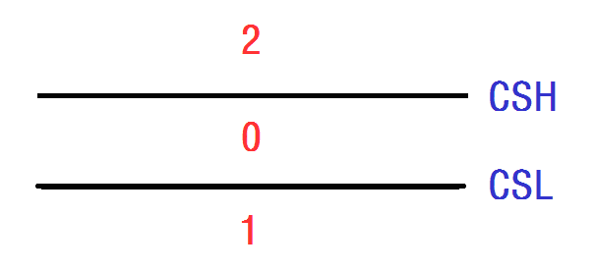
In the figure:
CSH​ — Power Factor Cut-off Threshold
CSL​ — Power Factor Switching-on Threshold
Zone Descriptions and Operation Methods:
No. | Zone Description | Action Plan
0 | Power factor qualified | No action
1* | Power factor less than power factor switching-on threshold | Switch on capacitor
2 | Power factor greater than power factor cut-off threshold | Switch off capacitor
Note:This area features an intelligent pre-calculation function for capacitor switching. That is, before switching in a capacitor, the controller performs a calculation first. If the resulting system power factor after switching would exceed the power factor cut-off threshold (CSH), the capacitor will not be switched in, to avoid hunting/oscillation.

4.2 Reactive Power Switching
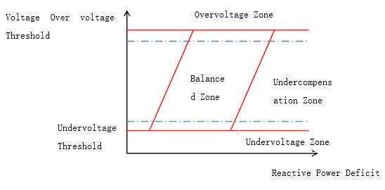

Controller switches capacitors based on reactive power.
Between the overvoltage and undervoltage thresholds:
When the reactive power deficit exceeds the switching-in threshold: switch in capacitors. To prevent hunting, switching in is blocked when voltage approaches the overvoltage threshold.
When the reactive power deficit is below the switching-out threshold: switch out capacitors. To prevent hunting, switching out is blocked when voltage approaches the undervoltage threshold.
If voltage drops below the undervoltage threshold, all switched-in capacitors are disconnected, and capacitor switching-in is blocked (undervoltage protection).
If voltage rises above the overvoltage threshold, all switched-in capacitors are disconnected, and capacitor switching-in is blocked (overvoltage protection).

4.3 Switching Modes
1) Cyclic switching mode: For equal-capacity capacitor banks, the controller follows a “first-switched-in, first-switched-out” strategy.
- Combination switching mode: For unequal-capacity capacitor banks, the controller selects the optimal capacity combination based on real-time measured reactive power.
- Filtering mode switching: The controller switches capacitors in sequence according to the reactive power deficit and filter harmonic order:
- When switching in: Capacitor banks with lower harmonic order (smaller index) are switched in first. If switching in bank m causes overcompensation, all banks with index ≥ m will not be switched in.
- When switching out: Capacitor banks with higher harmonic order (larger index) are switched out first. If switching out bank n causes undercompensation, all banks with index ≤ n will not be switched out.
- PV control mode: Supports four-quadrant operation. Based on reactive power data, the controller switches capacitors to meet reactive power compensation requirements in all four quadrants.

5 Capacitor Bank Protection Functions
Note: Protection principles may vary slightly depending on the device model; refer to the actual product for details.

5.1 Time-limited Instantaneous Overcurrent Protection (Stage I Current Protection)
Operating Conditions:
- Iac​≥Isd​
- Delay time t=Txd​
- Protection plate of the time-limited instantaneous overcurrent protection: Enabled
Action Result:
Alarm - trip the capacitor bank; manual reset required.
Where:
- Iac​: RMS value of the differential current
- Isd​: Setting value of the time-limited instantaneous overcurrent protection
- Txd​: Operating time setting value of the time-limited instantaneous overcurrent protection

5.2 Overcurrent Protection (Stage II Current Protection)
Operating Conditions:
- Iac​≥Id​
- Delay time t=Td​
- Protection plate of the overcurrent protection: Enabled
Action Result:
Alarm - trip the capacitor bank; manual reset required.
Where:
- Iac​: RMS value of the differential current
- Id​: Setting value of the overcurrent protection
- Td​: Operating time setting value of the overcurrent protection

5.3 Open-delta Voltage Protection
Operating Conditions:
- Uo​≥Usd​
- Delay time t=Td​
- Open-delta voltage protection protection plate: Enabled
Action Result:
Alarm and trip the capacitor bank; manual reset required.
Where:
- Uo​: RMS value of the capacitor bank open-delta voltage
- Usd​: Setting value of the open-delta voltage protection
- Td​: Operating time setting value of the open-delta voltage protection

5.4 Unbalanced Current Protection
Operating Conditions:
- Io​≥Isd​
- Delay time t=Td​
- Unbalanced current protection protection plate: Enabled
Action Result:
Alarm and trip the capacitor bank; manual reset required.
Where:
- Io​: RMS value of the capacitor bank unbalanced current
- Isd​: Setting value of the unbalanced current protection
- Td​: Operating time setting value of the unbalanced current protection

5.5 Harmonic Current Protection
Operating Conditions:
- THDIc≥THDIs
- Delay time t=Td​
- Harmonic current protection protection plate: Enabled
Action Result:
Alarm and trip the capacitor bank; auto-reset. (Alarm-only or alarm + trip is selectable.)
Where:
- THDIc: Total harmonic current distortion of the capacitor bank
- THDIs: Setting value of the capacitor bank harmonic current distortion
- Td​: Operating time setting value of the harmonic current protection

5.6 Harmonic Voltage Protection
Operating Conditions:
- THDU≥THDUs
- Delay time t=Td​
- Harmonic voltage protection protection plate: Enabled
Action Result:
Alarm and trip the capacitor bank; auto-reset. (Alarm-only or alarm + trip is selectable.)
Where:
- THDU: Total harmonic voltage distortion of the system
- THDUs: Setting value of the harmonic voltage distortion
- Td​: Operating time setting value of the harmonic voltage protection

5.7 Overvoltage Protection
Operating Conditions:
- U≥Ush​
- Delay time t=Td​
- Overvoltage protection plate: Enabled
Action Result:
Alarm and trip the capacitor bank; auto-reset. (Alarm-only or alarm + trip is selectable.)
Where:
- U: System voltage
- Ush​: Overvoltage setting value
- Td​: Operating time setting value of the overvoltage protection

5.8 Undervoltage Protection
Operating Conditions:
- U≤Usl​
- Delay time t=Td​
- Undervoltage protection plate: Enabled
Action Result:
Alarm and trip the capacitor bank; auto-reset. (Alarm-only or alarm + trip is selectable.)
Where:
- U: System voltage
- Usl​: Undervoltage setting value
- Td​: Operating time setting value of the undervoltage protection

High-temperature Fan Start-up* (This is an optional setting function)
Operating Conditions:
- W≥Ws1​
- Delay time t=Td​
- Action Result:
- Start the fan; auto-reset. (Fan start or alarm can be selected.)
Where:
- W: System temperature (corrected from the text error)
- Ws1​: Temperature setting value for fan start-up
- Td​: Operating time setting value for fan start-up

5.10 Over-temperature Protection* (This is an optional setting function)
Operating Conditions:
- W≥Ws2​
- Delay time t=Td​
- Over-temperature protection plate: Enabled
Action Result:
Start the fan, trigger alarm, and trip the capacitor bank; auto-reset. (Alarm-only or alarm + trip can be selected.)
Where:
- W: System temperature (corrected from the text error)
- Ws2​: Over-temperature setting value
- Td​: Operating time setting value for over-temperature protection

6 Menu Operation Instructions
The controller adopts a resistive 7-inch color touch screen with 800×480 resolution as its human-machine interface. All parameter settings and data viewing can be performed directly on the LCD screen.

6.1 Main Menu
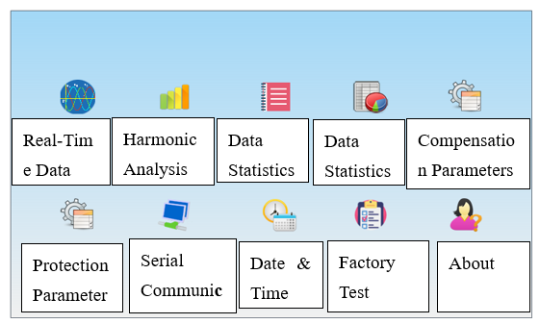

As shown in the figure, the main menu interface includes ten menu options. Click the corresponding icon directly to enter each sub-level interface.

6.2 Real-time Data
As shown in the figure, the real-time data screen consists of one interface, a reset button, and a return button. The displayed data includes:
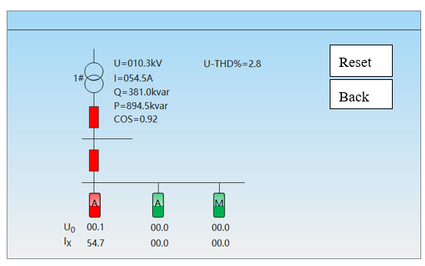
- System real-time analog quantities: system voltage, current, reactive power, active power, power factor
- Analog quantities for 1~3 capacitor banks: unbalanced voltage / unbalanced current, current, temperature
- Main transformer switch status, upstream switchgear status, and 1~3 capacitor bank switch status (green indicates open state, red indicates closed state)
- 1~3 capacitor bank operating status:"A": Automatic mode "M": Blocked mode "U": Unbalanced voltage "1": Stage I overcurrent "2": Stage II overcurrent "H": Closing failure "F": Opening failure "T": Communication error "I": Unbalanced current "W": Over-temperature "S": Temperature sensor fault Fan start icon (temperature control and protection is an optional function and not available on the standard model).

6.3 Harmonic Analysis
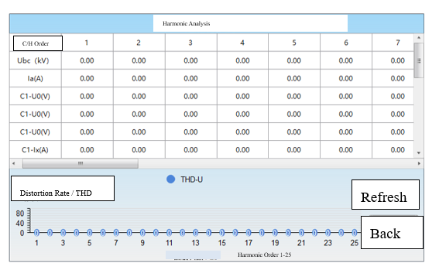
As shown in the figure, the real-time data screen consists of one interface, a refresh button, and a return button. It displays the 1st to 25th harmonic data in both list format and bar chart format (click the refresh button each time you view the data). The displayed data includes:
- Ubc​ (kV): 1st to 25th order system harmonic voltage
- Ia​ (A): 1st to 25th order system harmonic current
- C1−U0 (V): 1st to 25th order harmonic voltage of Capacitor Bank 1
- C2−U0 (V): 1st to 25th order harmonic voltage of Capacitor Bank 2
- C3−U0 (V): 1st to 25th order harmonic voltage of Capacitor Bank 3
- C1−Ix (A): 1st to 25th order harmonic current of Capacitor Bank 1
- C2−Ix (A): 1st to 25th order harmonic current of Capacitor Bank 2
- C3−Ix (A): 1st to 25th order harmonic current of Capacitor Bank 3

Operation Records
Operation Records
No. | Time | Information | Data
1 | 24-04-08 15:40:07 | Bank 1 opening failure | 0.00
2 | 24-04-08 15:40:07 | Bank 8 closing | 0.00
3 | 24-04-08 15:40:03 | Bank 7 closing failure | 0.00
4 | 24-04-05 20:34:27 | Bank 6 communication restored | 0.00
5 | 24-04-05 20:32:19 | Bank 6 communication failure | 0.00
6 | 24-04-05 20:32:19 | Bank 5 closing | 0.00
7 | 24-04-05 20:32:19 | Bank 4 closing | 0.00
8 | 24-04-05 20:32:19 | Bank 3 closing | 0.00
9 | 24-04-05 20:32:14 | Bank 2 closing | 0.00
10 | 24-04-05 20:25:34 | Bank 1 closing | 0.00

As shown in the figure, the real-time data screen has 1 interface and 4 buttons. It can store up to 300 operation records and alarm events, which are not affected by power outages, making it easy to review past operations and faults.
- Hardware initialization fault information.
- Switch-on and switch-off actions of each capacitor bank, along with date, time, and real-time values.
- Various alarm events, along with date, time, and operating values.

6.5 Data Statistics
Counts the number of switch-on/off operations for each capacitor bank in the current month, as well as hourly voltage, current, active power, and power factor data. The operation counts can be cleared manually or automatically by the controller at the end of each month.
Switching Count
Name | Closing Count | Opening Count
Bank 1 | 00035 | 00032
Bank 2 | 00028 | 00024
Bank 3 | 00019 | 00016
Bank 4 | 00018 | 00013
Refresh | Clear | Back

6.6 Compensation Parameters
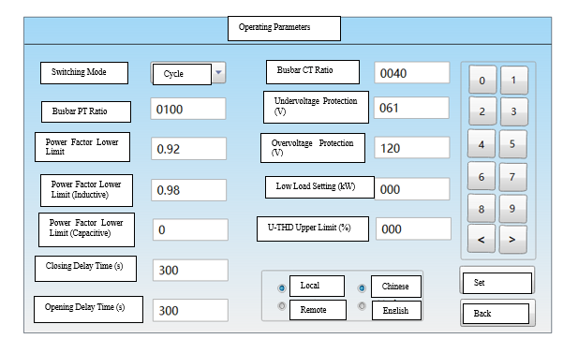
Compensation parameters are the control and setting parameters for the controller (the default password to enter is: 00000). These can be set by clicking the numeric keypad on the right. After configuration, click the Set button to save the changes. For details of the setting parameters, please refer to the table below:
Parameter | Value Range | Unit | Remarks
Switching Mode | Cycle / Combination / Filter / PV | - | Four operation modes to meet control needs in different scenarios.
Busbar PT Ratio | 1–9999 | - | Ratio of the sampling potential transformer. For example, if the transformer ratio is 10000:100, set to 100. Default = 100
Power Factor Lower Limit | 0.01–0.99 | - | Switch-in threshold: If the system power factor is below this value AND the reactive power is greater than the capacity of the capacitor bank to be switched in, the capacitor bank will be switched in. Default = 0.92
Power Factor Upper Limit - L | 0.01–0.99 | - | Switch-out threshold: If the system power factor rises above this value, the capacitor bank will be switched out. "L" indicates inductive, i.e., overcompensation is not allowed. Default = 0.98
Power Factor Upper Limit - C | 0.01–0.99 | - | Switch-out threshold: If the system power factor rises above this value, the capacitor bank will be switched out. "C" indicates capacitive, i.e., overcompensation is allowed. Default = 0.98
Switch-in Delay Time | 1–999 | s | Delay time for capacitor switching in. Default = 300
Switch-out Delay Time | 1–999 | s | Delay time for capacitor switching out. Default = 150
Busbar CT Ratio | 1–9999 | - | Ratio of the sampling current transformer. For example, if the transformer ratio is 1000A:5A, set to 200. Default = 40
Low Voltage Protection | 0–99.9 | % | After undervoltage, the voltage must rise above the undervoltage threshold + hysteresis voltage to clear the undervoltage alarm. Default = 80
Overvoltage Protection | 0.1–999.9 | s | After overvoltage, the voltage must drop below the overvoltage threshold - hysteresis voltage to clear the overvoltage alarm. Default = 120
Low Load Blocking | 0–999 | kW | When the system active power falls below this value, the controller will switch out all capacitors and block further switchin in. Set to 0 to disable this function. Default = 0
Upper Limit of Voltage THD | — | — | When the voltage total harmonic distortion (THD) exceeds this value, all capacitors will be switched out until the alarm clears. Set to 0 to disable this function. Default = 0
Upper Limit of Current THD | — | — | When the current total harmonic distortion (THD) exceeds this value, all capacitors will be switched out until the alarm clears. Set to 0 to disable this function. Default = 0
Local / Remote | 0 / 1 | - | Local: Local control mode (automatic). Remote: Remote operation mode, allowing capacitor bank control via a remote communication backend. Default = Local
Chinese / English | 0 / 1 | - | Chinese: Chinese interface  English: English interface
Note: The above parameters include all items for different controller versions. The actual parameters depend on the specific controller model used.

6.7 Capacitor Parameters (The table below shows parameters for a single bank; the parameters are identical for all 3 banks)
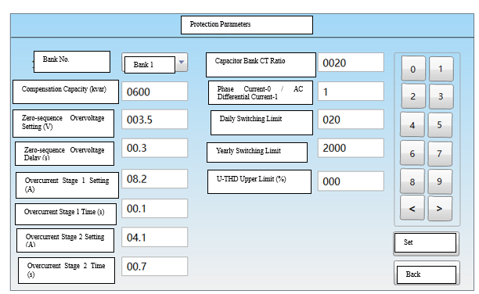

Parameter | Value Range | Unit | Remarks
Compensation Capacity | 0–9999 | kvar | Actual output capacity of the corresponding capacitor bank. Default = 100
Zero-sequence Overvoltage Setting | 0–99.99 | V | Overvoltage protection setting for the capacitor open-delta voltage. When the open-delta voltage exceeds this value, the corresponding capacitor will be tripped and blocked. Manual unlock is required after fault clearance. Set to 0 to disable this function. Default = 0
Zero-sequence Overvoltage Delay Time | 0–9.99 | s | Delay time for open-delta overvoltage protection. Default = 0.5
Stage I & II Overcurrent Setting | 0–99.9 | A | Unbalanced current protection setting for the capacitor. When the unbalanced current exceeds this value, the corresponding capacitor will be tripped and blocked. Manual unlock is required after fault clearance. Set to 0 to disable this function. Default = 0
Stage I & II Overcurrent Delay Time | 0–9.99 | s | Delay time for unbalanced current protection. Default = 0.5
Capacitor CT Ratio | 1–9999 | - | Ratio of the capacitor bank current transformer. Default = 20
*Stage I Temperature (Fan Start) | 0–999 | ℃ | Capacitor bank temperature setting. When the measured temperature exceeds this value, the fan will start after a delay. Set to 0 to disable this function.
*Stage II Temperature (Alarm & Trip) | 0–999 | ℃ | Capacitor bank temperature setting. When the measured temperature exceeds this value, the corresponding capacitor will be tripped and an alarm will be triggered. Set to 0 to disable this function.
Single-phase / Differential Current | 0 / 1 | - | 0: Phase current wiring mode  1: Differential current wiring mode. Default = 1

Note: The above parameters include all items for different controller versions. The actual parameters depend on the specific controller model used.

6.8 Serial Communication
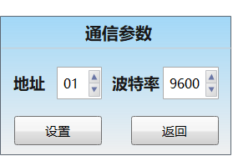
Back
Set
Baud Rate
Address
Communication Parameters
The device supports communication with an RTU via the RS-485 serial port using the ModBus protocol. This function allows the unit to transmit its operating status, real-time measurement data, real-time events, and switch status changes to the superior dispatch system, enabling the "four remote" functions (telemetry, telecommand, telesignaling, and teleadjusting).

6.9 Date and Time
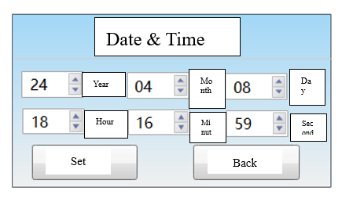
Setting the controller's time.

6.10 Factory Test
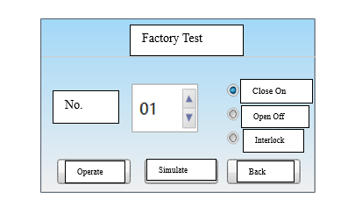
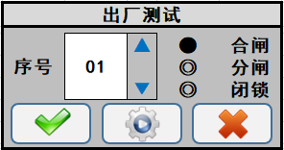
Provides local operation functions for closing and opening the group switches, and tests the protection interlock circuits. The factory simulation operation function simulates under-compensation switching in, over-compensation switching out, and voltage protection functions.

7 Equipment Installation, Terminal Wiring, and Power-On Operation

7.1Cutout Dimensions
The controller requires a cutout of 214 × 156 mm. It is designed for panel-mount installation with snap-in clips.
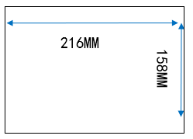

7.2 Controller Terminal Wiring
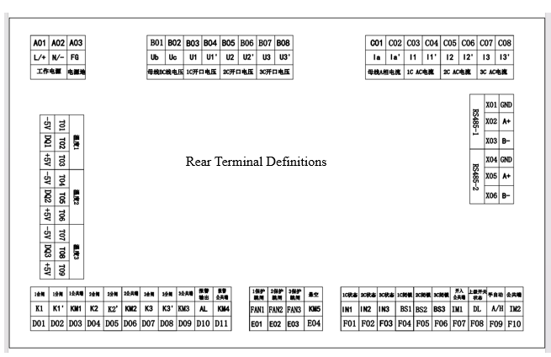
Please strictly follow the "Terminal Definition Diagram" for wiring. Do not power on the device until the wiring has been verified to be correct.
Note: Please distinguish between the standard and non-standard versions.

7.3 Powering On the Device and Checking Status
After powering on, the normal status is that the LCD screen lights up, and the "Power" and "Run" indicators (green) on the right side of the LCD flash.

Parameter Setting
After the device is powered on, please set the controller parameters according to the actual on-site grouping and capacitor capacity. For the parameter setting method, please refer to the descriptions in the 6 sections above.

8 Device Commissioning

8.1 Purpose of Commissioning
To verify the correctness of the wiring between the controller's rear terminals and other secondary circuits, preventing incorrect connections.

8.2 Commissioning Methods
1) Analog Interface Commissioning
Apply analog quantities (voltage, current, △θ) from a standard power source to the terminal block. Check if the bus voltage, bus current, capacitor current, open-delta voltage/differential current, active power, reactive power, and phase displayed on the operation interface match the actual conditions.
Note: Before applying analog quantities, the PT must be disconnected to prevent feedback power to the primary circuit.
2) Binary Input Interface Commissioning
Trigger status changes for each switch one by one, and check if the corresponding switch status on the operation interface changes correctly.
3) Binary Output Interface Commissioning
① Manual Switching Test
After setting the selector switch to the "Manual" position, set the controller's "Operation Status" to "Manual" and the capacitor switching control 压板 to "Enabled". Manual switching control of the capacitor banks can then be performed (no blocking or protection should be active at this time). First select the bank, then execute the action type: Close or Open (only uncharged banks can be closed, and charged banks can be opened).
Note: Perform both the Close and Open actions for all grouped switches.
② Blocking, Alarm & Trip Test
Taking the open-delta voltage protection as an example: first set the open-delta protection parameters, then simulate the protection conditions for each bank. Check if the corresponding trip signals (pulse signals) and alarm signals (latched signals) are output correctly.

8.3 Common Abnormal Conditions and Troubleshooting

No. | Symptom | Cause | Resolution
1 | Protection information is displayed, e.g., "Undervoltage Protection", "Overcurrent Protection", etc. | Protection has operated. | After the fault is cleared, reset the controller in the data setting interface.
2 | Over/undervoltage abnormality is displayed. | Voltage abnormality during automatic switching. | a. Restore the bus voltage to within the normal range; the abnormality will clear automatically.  b. Switch the operating mode to manual.
3 | Alphabetic characters are displayed inside the capacitor bank switch status. | Capacitor bank fault. | After the fault is cleared, reset the controller in the data setting interface.

9 After-sales Commitment
For any products purchased from our company, we hereby make the following product quality guarantee commitments to customers:

9.1 Product Quality Commitment
- Complete quality records and test data are kept for product manufacturing and inspection.
- All procedures including raw material procurement and product production are strictly controlled in accordance with CQC quality certification standards, ensuring every process is under quality control so as to guarantee product quality.
- All finished products are 100% inspected in strict accordance with inspection procedures. The one-time acceptance qualification rate of finished products reaches 99%, and the sampling inspection qualification rate also reaches 99%.
- For product performance testing, customers are sincerely invited to conduct full-process and full-performance on-site inspection. Products will only be packed and delivered after being confirmed qualified.

9.2 Product Price Commitment
- To ensure high reliability and advanced performance of the system, only high-quality well-known brand materials at home and abroad are adopted for system selection.
- Under the same competitive conditions, our company sincerely provides products to customers at the most favorable price without reducing technical performance or replacing product components.

9.3 Delivery Time Commitment
- Product delivery will be arranged in accordance with customers’ requirements as far as possible. For special demands requiring early completion, our company can arrange dedicated production and installation to fully meet customer needs.
- Upon product delivery, our company shall provide the following documents to customers:
① Operation Manual
② Product and Packing List

9.4 After-sales Service Commitment
- Service Tenet: Prompt, Decisive, Accurate, Considerate, Thorough
- Service Goal: Win customer satisfaction through high-quality service
- Service Efficiency: In case of equipment failure within or outside the warranty period, our maintenance personnel will arrive at the site and start maintenance within 24 hours upon receiving the notification.
- Service Principle: The product warranty period is twelve months. Within the warranty period, repair and replacement of damaged parts caused by quality problems are free of charge. For component damage outside the warranty period, only the cost price of spare parts will be charged. For equipment damage caused by human factors, both maintenance service and supplied spare parts shall be charged at cost price.

9.5 Order Instructions
When purchasing products from our company, customers shall specify the following information:
- Product name, model and quantity
- Provide detailed technical requirements if any special demands are needed.

